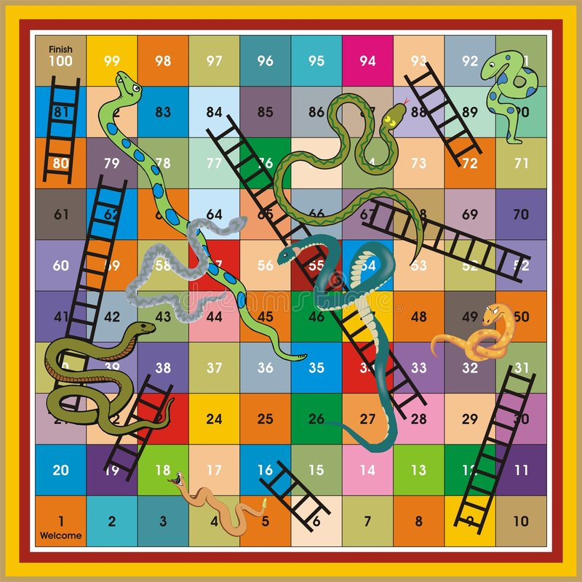
Printable Snakes & Ladders
Cut out the counters below and all you need is a dice

